**Introduction to Functions of Several Variables**

Table of Contents

Properties 3

Graphs (2 Variables) 4

Level Curves 5

Level Surfaces 7

Functions may have **multiple independent variables**. If is a function with several variables, then is the **domain**. The set of values we get for for this domain is the **range**.

For for example, the domain is . Based on this, we can tell that the graph should be a sphere with radius .

## Properties

,

It is not possible to form the **composite** of two functions. However, if one of the functions has several variables and the other has just one, a composite can be formed.

, where is a function with a single variable.

Functions of multiple variables that can be written as a **sum of functions** in the form are called **polynomial functions**. For example, .

The quotient of two polynomial functions is called a **rational function**.

## Graphs (2 Variables)

The graph of a function of two variables is the set of all point, , for which and is within the domain of . Geometrically, this is a **surface** in space.

For a particular graph, the **projection** onto the plane is , the domain of .

## Level Curves

Another way to visualize a function with two variables is to use a **scalar field** in which the scalar is assigned to the point .

A scalar field can be characterized by **level curves** or **contour lines** along which the value of is constant. Essentially, we have a line joining several points for which the same value can be found for . This value is written on the line. Several types of geographical maps use contour lines.

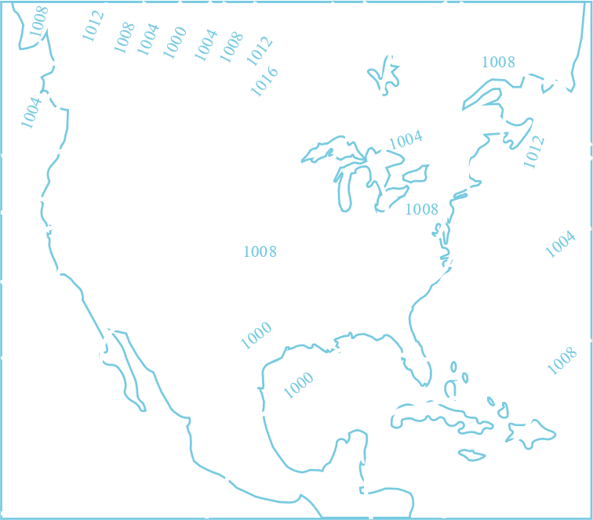

Consider that we have a function .

Because of this, the maximum possible value of is .

If we use a **contour map**, we can sketch a 3D graph on a 2D plane like this:



## Level Surfaces

The concept of Level Curves, when extended to the third dimension, gives us **Level Surfaces**.

If , we get ellipsoids.